2016 CSEO Distance Analysis
by
Jennifer Stahl

methods

summary
A total of 32 line transects were performed in CSEO management area from August 17–24, 2016 using the ROV “Buttercup”. For yelloweye rockfish the following information was collected: 3D point measurement (includes perpendicular distance), fish length measurements, fish stage based upon morphological appearance, and behavior. ROV video was reviewed to determine the official start and end times of each line transect and to determine valid portions of the dive, i.e. where the ROV was moving forward and the seafloor was visible. Adult and subadult yelloweye rockfish observed during valid segments of line transect dives were considered for Distance analysis; juveniles were excluded from analysis.
The left and right sides of each line transect were sampled and the data pooled for the Distance analysis. In Distance, a sampling fraction is defined as 1 if both sides of the line are sampled and as 0.5 if only one side of the transect is sampled as occurred for the submersible surveys. A correction factor was applied for surveys with a sampling fraction of 0.5 in order to obtain the density estimate using data from only one side of the transect line.

Data Exploration
Histograms of binned fish distance from the line transect were created in Excel. Binned data were examined for patterns that may indicate avoidance (i.e. an increase in the pattern of observations from the origin to a particular distance) or attraction (i.e. a spike of observations at the origin) behavior by yelloweye rockfish and to determine appropriate data structure for input into the Distance program, i.e. a model with a shoulder and a decreasing frequency of observations with distance from the ROV. The following bins were examined: 0.5-ft, 1-ft, 1.5-ft, 2-ft, 2.5-ft bins (Figure 1–3).

Distance Analysis
Data
Fish density was estimated for three different data sets using Distance software:
- Analysis 1 for age-structured model- All valid adults and subadults
- Analysis 2 for SAFE- All valid adults and subadults ≥ 340 mm and with no length information
- Analysis 3 for SAFE – All valid adults and only subadults ≥ 340 mm; subadults with no length data were excluded.
Analyses were performed with different data sets, because the current stock assessment needs differ from the age-structured model that is being explored for future stock assessments.
For the current stock assessment (SAFE document presented to the council), two analyses were performed: Analysis 2 and Analysis 3. Only fish ≥340 mm, the minimum size of (>99.9%) fish captured across management areas in the directed fishery (2001–2015) were included, because the current assessment is not modeled using selectivity of the longline gear. If all subadult and adult fish were included in the density estimate as available biomass for exploitation, there would be a risk of overharvest because the commercial fishing gear does not catch smaller subadults. An age-structured assessment model is in development that will include selectivity as well as weight at age for the biomass calculation. Currently, mean weight is used to estimate biomass from the density estimates. Examinations to include weight at age or weight at length to more accurately calculate biomass are ongoing. For the 2012 CSEO and the 2016 NSEO analyses subadults with no length data were excluded because the average length of subadults measured during the transects was smaller than the minimum length of yelloweye observed in the directed fishery (340 mm). However, in 2013 and 2015 yelloweye subadults with no length data were included, because the average length of subadults in the transects was ≥ 340 mm (467 mm in 2013 and 383 mm in 2015). The average length of subadults in the transects for CSEO in 2016 was 377 mm with all length data included and 437 mm when lengths were removed with a horizontal direction >30 and precision >40. Consequently, I suggest Analysis 2 that includes subadults with no length information in the SAFE for the 2016 CSEO survey.
For the age-structured model in development, no adults or subadults were excluded based on size (Analysis 1). This age-structured model accounts for selectivity, i.e. small fish contribute proportionately less to the spawning stock biomass than larger fish.
Key functions and adjustment terms
Models using the half normal cosine and the hazard rate cosine were explored in the distance analyses. The uniform and negative exponential models were not considered, because the negative exponential is generally used for salvaging poorly collected data and the uniform assumes that there is no decrease in probability to the effective width of the key function (T. Quinn pers. com.).
Data binning
Analyses were examined with and without data binning. If no binning was used then the analyses were performed with the exact distance data. Data binning was explored to determine if it would improve the results for the analyses. Data binning may increase the robustness of the results. Data binning was used for previous submersible surveys because observers tend to round visually estimated distances; therefore, creating measurement error. The ROV provides nearly exact distance measurements to yelloweye rockfish; however, there may still be some error in distances due to the clarity of the video and an inability to always identify the same point in both the left and right stereo cameras. The following data bins were explored in the Distance software to determine which bin would produce the best fit of the data: 0.5-ft, 1-ft, 1.5-ft, 2-ft, 2.5-ft. For analyses that were performed without data binning, bins were selected by the Distance program for the chi-square test diagnostics; these bins only affect the results of the chi-square tests and do not affect the density estimate.
Data Truncation
Distance data are often truncated in order to prevent the tail of the model from overly influencing the model fit, because it is most important for the model to fit near the origin of the transect line. Terry Quinn (pers. com.) suggests truncating 5-10% for distance data; Buckland et al. (2001) says this method is a simple way to truncate data but may produce unsatisfactory results. Data truncation for distances greater than 12 ft were explored for unbinned data and 1 ft, 1.5 ft , and 2 ft bins, data binned at 2.5 ft were truncated at 12.5 ft.
Choosing a model
Distance analysis results were examined to determine if a viable density estimate could be arrived at using the 2016 CSEO ROV data. Adequate model fit was determined visually and by examining diagnostic tests, including Q-Q plots, Chi-square and Kolmogorov-Smirnov (K-S) goodness of fit tests. In addition, the coefficient of variation (CV) was examined to determine precision.
The preferred model key function and adjustment term was chosen against other models with the same binning and truncation scheme by comparing the AIC values, model fits, and CV values between models. To determine if binning or truncation improved the model results and determine what would be the best binning scheme for the data, the CV values and model fits were compared. However, the AIC cannot be used to compare between models with differing binning or truncation schemes.
Visual examination was used to identify a model with a good fit at the origin, a shoulder, and a shape that is biologically realistic, e.g. a model with a decreasing probability of detection with distance rather than a uniform probability of detection throughout the observed distances. The K-S and X² goodness of fit tests are used to determine if the data fit the model well. The K-S test is considered to be a better goodness of fit test; however, it only provides diagnostics if data are not binned. If the K-S or chi-square p-values are not significant (p > 0.05) it suggests the model has a reasonable fit with no significant deviations in the model. The Q-Q plot is also used to evaluate model fit for models with no binning. Models where the detection function is fit to the raw data rather than to binned data, may still be evaluated with the X² goodness of fit, by assessing how well selected binned data fits the detection model.
The AIC value was used to determine the model with the best key function and adjustment term for models with the same binning and truncation schemes. A lower AIC score is preferred and the AIC score incorporates the number of parameters, giving a penalty for more parameters. The ∆AIC indicates the degree to which the model with the lowest AIC is preferred over other models. A ∆AIC<2 indicates no credible evidence of superiority of the lower AIC model over the higher, ∆AIC 2–4 weak evidence, 4–7 definite evidence, 7–10 strong evidence, and >10 very strong evidence.
The precision of the density estimates was determined by examining the CV of the density estimate and the variance components of the density estimate. The CV was used to determine if a model had good precision. If a density estimate has a CV<20% then the model is considered to have sufficiently high precision. The variance of the density estimate is composed of the variance due to the detection function and the variance due to the encounter rate. As the model fit to the data improves, the variance due to the detection function decreases. The variance in the encounter rate is due to the variability in the number of observations among transects.

Results/Discussion
Of the 32 valid line transects a total of 164 yelloweye rockfish were observed, 151 adults and 13 subadults. On average 5 yelloweye adults or subadults were observed per transect (Table 1). No yelloweye rockfish were observed on one of the 2016 CSEO transects. A maximum of 13 yelloweye were observed on a single transect (Table 1).
Length measurements were examined by fish stage based upon morphological appearance to determine which yelloweye to include in the density estimates. Lengths were collected from 91 adults, 10 subadults, and 14 juveniles. These data were edited to exclude measurements with large errors (horizontal angle>30°, precision >40 mm, and root mean square error (RMSE) >10 mm from the average, minimum, and maximum length calculations. However, each of these errors alone may not cause invalid length measurements. The 2016 CSEO adult average length was 509 mm with lengths ranging from 386–667 mm; the subadult average length was 347 mm with lengths ranging from 285–389 mm. Juvenile average length was 226 mm with lengths ranging from 165–321. Some overlap occurred between the length range of subadults and juveniles as well as between subadults and adults; no overlap occurred between juveniles and adults. There is subjectivity in morphological classification, e.g., some subadults may be adults and vice versa. All juveniles were <340 mm and excluded from the distance analysis. Juveniles have not been included in the density analyses in previous years. It may be difficult to obtain valid density estimates for juvenile yelloweye rockfish, because they are more difficult to identify among other small rockfish, and they may exhibit different behaviors such as avoidance of the survey vehicle or be more likely to seek cover. Four subadults were <340 mm and were excluded from the distance analysis using current stock assessment methods. Prior to 2012, all subadults and adults were included in the density analysis because no length data were available for the submersible survey; however, size and morphology would have been easier to judge in-situ from the submersible than from the ROV video.
The 2016 CSEO ROV survey results suggest that using an ROV to conduct line transect sampling continues to be a valid method to estimate yelloweye rockfish density. Models were produced that fit the data well, the assumptions of distance sampling were met, and CV estimates indicate reasonable precision in the density estimate (Table 2). In 2016 CSEO management area, the majority of the variance of the density estimates was due to the variability of the encounter rate with the remaining variance due to the detection probability (Table 2). The variance due to the detection probability decreases as the fit of the model to the data improves; the low variance due to the detection probability indicates that the data fits the model well. However, the variability due to the detection probability was lower in previous surveys.
Models with good fits to the data were obtained for all three analyses. The best models had half normal key functions with a cosine series expansion term; these models had a probability detection function with a small shoulder. It is preferred to have a model with a larger shoulder extending from the transect origin before declining at larger distances (Figure 4–6). In the past ROV surveys, a hazard rate key function was preferred, which had a shoulder that extended out to four to six feet from the origin. However, while model diagnostics were good, the hazard rate models produced shapes that were biologically unrealistic for the 2016 CSEO survey (Appendix 1–3) and were excluded from further consideration. The steeper decline in the number of yelloweye observed from the origin may be due to the terrain. In high relief habitat it may be more difficult to observe yelloweye close to the ROV if they are in cracks or behind rocks. We did a review of the belly camera to ensure that all fish within close range of the transect line were observed if not obstructed. The AIC values were generally pretty similar between models, usually the difference wasn’t large enough for a model to be preferred using only the AIC as criteria (Appendix 1–3).
Models without binning were preferred for the 2016 CSEO data. Unbinned data retains data variability, however, binning data can improve the robustness in the density estimator if errors in measurement occur, and/or heaping or avoidance behaviors are present. With the submersible survey, data were grouped because distances were estimated by observers, introducing both error in distance measurements and heaping of data due to rounding by the observer (i.e. 2ft, 10 ft, 15, etc.). With the ROV survey, stereo cameras allow measurements to be taken with minimal error. In addition, there was no indication of avoidance behavior in the detection function (i.e. increase in frequency histograms from origin to some distance; Figure 1–3) or in the behavior of yelloweye rockfish.
In CSEO in 2016, models without data truncation were chosen and fit the data better (Appendix 1–Appendix 3). Truncation is employed to prevent the tail of the model from overly influencing the overall model fit. Data were generally truncated for the submersible surveys with yelloweye rockfish sometimes identifiable at distances as great as 30 ft. Fish observations at greater distances occur less frequently using the ROV as compared to using the submersible, where there was possibility of observations at greater distances. Fish were observed to about 15 ft in CSEO in 2016. In 2012 CSEO, 2013 SSEO, and the 2016 NSEO surveys, data models were preferred with no truncation. No fish were observed past 12 feet in these years. In 2015, the model was improved with truncation after 11 feet with four fish observed at distances greater and out to 16ft. In 2016 CSEO five fish were observed at distances greater than 12 ft.
Good CV estimates were obtained for CSEO in 2016 with 14% for each of the models and an encounter rate of 0.005 yelloweye/m for each model. The 2016 CSEO encounter rates are higher than what was observed in CSEO in 2012 (0.003 yelloweye/m) and in SSEO in 2013 (0.004 yelloweye/m); however are much lower than the observed encounter rate in EYKT (0.008 yelloweye/m), which may support higher densities of yelloweye rockfish than other areas (Table 2).
Valid density estimates were obtained with no violations of distance sampling assumptions. A majority of adult and subadult (91%) yelloweye rockfish exhibited neutral behaviors, such as milling, hovering, resting on the bottom, swimming actively in the frame, or seeking cover when first observed by the ROV; 4% of adults and subadults were observed moving into the frame slowly or quickly and 2% of adults and subadults were observed moving out of the frame slowly or quickly. The remaining 2% of yelloweye rockfish were exhibited behaviors such as feeding or chasing other fish. The sighting frequency histograms and the probability detection functions indicate a slightly higher instance of fish observed at the origin (Figures 1–3). Because only 4% of adults were observed moving into the frame compared to 2% moving out of the frame, it is likely that the larger number of observations at the origin may be due to the high relief or other complex habitat being more likely to obstruct fish away from the origin and that the origin was well covered with the belly camera review. If attraction behavior did occur, then the spike at the origin of the probability detection function would likely be larger and more fish would be observed moving into the frame rather than milling or hovering around at first sighting (Buckland et al. 2001).
In CSEO in 2016, yelloweye rockfish density was 1,142 yelloweye/km² for the analysis that included all subadults, 1,101 yelloweye/km² for the analysis that included subadults ≥340 mm and with no length information, and 1,073 yelloweye/km² with only subadults ≥340 mm. The density estimates were similar between these analyses, because only three subadult yelloweye were excluded in Analysis 2 and only six subadults were excluded from Analysis 3. The 2016 CSEO density estimate was much higher than the 2012 estimate of 752 yelloweye/km² but was similar to the 2007 submersible estimate of 1,050 yelloweye/km² (Table 5). Since the last survey of CSEO in 2012, the district was open to directed fishing of demersal shelf rockfish in 2013 but closed in 2014, 2015, and 2016. However, this area was open to halibut and lingcod commercial fishing; these fisheries catch yelloweye rockfish as bycatch.

References
Buckland, S. T., D. R. Anderson, K. P Burnham, and J. L. Laake, D. L. Borchers, and L. Thomas. 2001. Introduction to Distance Sampling. Oxford University Press.

TABLES AND FIGURES

Table 1. ROV survey summaries and distance inputs.
Year | 2012 | 2013 | 2015 | 2015 | 2016 | 2016 | 2016 | 2016 | 2016
Management Area | CSEO | SSEO | EYKT | EYKT | NSEO | NSEO | CSEO | CSEO | CSEO
Model Data | AD & SUB≥340 mm | AD & SUB≥340 mm | AD & All Subadults | AD & SUB≥340 mm | AD & All Subadults | AD & SUB≥340 mm | AD & All Subadults | AD & SUB≥340 mm& with no lengths | AD & SUB≥340 mm
Model Use | SAFE | SAFE | Age Model | SAFE | Age Model | SAFE | Age Model | SAFE | SAFE
# line transects | 46 | 31 | 33 | 33 | 36 | 36 | 32 | 32 | 32
Meters surveyed | 38,590 | 30,439 | 22,896 | 22,896 | 34,435 | 34,435 | 30,726 | 30,726 | 30,726
# transects w/o ye | 7 | 8 | 2 | 2 | 7 | 8 | 1 | 1 | 1
Avg ye per transect | 2.6 | 3.4 | 8.4 | 7.7 | 4.7 | 3.5 | 5.3 | 5.2 | 5.1
Max. ye per transect | 9 | 15 | 60 | 60 | 20 | 16 | 13 | 13 | 13
# AD & SUB in model | 118³ | 118 | 255 | 251² | 170 | 125 | 164 | 160 | 157
# AD in model⁵ | 112 | 93 | 240 | 240 | 119 | 119 | 151 | 151 | 151
# SUB in model⁵ | 6³ | 25 | 15 | 11² | 51 | 6 | 13 | 9 | 6
Max. distance (ft) ye⁵ | 10.39 | 10.86 | 11 | 11 | 11.5 | 11.5 | 14.7 | 14.7 | 14.7

Year | 2012 | 2013 | 2015 | 2015 | 2016 | 2016 | 2016 | 2016 | 2016
Management Area | CSEO | SSEO | EYKT | EYKT | NSEO | NSEO | CSEO | CSEO | CSEO
Model Data | AD & SUB>340 mm | AD & SUB>340 mm | AD & All SUB | AD & SUB>340 | AD & All SUB | AD & SUB>340 | AD & All SUB | AD & SUB>340  & no lengths | AD & SUB>340
Model Use | SAFE | SAFE | Age Model | SAFE | Age Model | SAFE | Age Model | SAFE | SAFE
Density (ye/ km²) | 752 | 986 | 1796 | 1755 | 960 | 701 | 1142 | 1101 | 1073
Lower CI (95%) Density | 586 | 641 | 1097 | 1065 | 675 | 476 | 870 | 833 | 813
Upper CI (95%) Density | 966 | 1517 | 2941 | 2891 | 1366 | 1033 | 1499 | 1454 | 1416
CV of Density | 0.13 | 0.22 | 0.25 | 0.25 | 0.18 | 0.20 | 0.14 | 0.14 | 0.14
Variance components
- Detection probability | 18% | 8% | 3% | 3% | 6% | 9% | 22% | 22% | 23%
-Encounter rate | 82% | 92% | 97% | 97% | 94% | 91% | 78% | 78% | 77%
Encounter rate (yelloweye/m) | 0.003 | 0.004 | 0.008 | 0.008 | 0.005 | 0.004 | 0.005 | 0.005 | 0.005
Effective strip width (ft) | 6.7 | 6.5 | 7.3 | 7.3 | 8.4 | 8.5 | 7.8 | 7.8 | 7.8
Table 2. Distance outputs for ROV surveys.

Table 3. Juveniles and subadults observed during ROV surveys.
Year | Management area | Juveniles | Subadults | Subadults <340 mm | Subadults >340 mm | Subadults no length data | Juvenile average length (mm) | Subadult average length (mm)
2012 | CSEO | 30 | 13 | 7 | 5 | 1 | 249 | 339
20136 | SSEO | 10 | 25 | 0 | 8 | 17 | 225 | 467
2015 | EYKT | 61 | 15 | 4 | 9 | 2 | 242 | 383
2016 | NSEO | 86 | 51 | 30 | 6 | 15 | 197 | 309
2016 | CSEO | 22 | 13 | 4 | 6 | 3 | 226 | 347

Table 4. Juveniles and subadults observed during submersible surveys.
Year | Management area | Juveniles | Subadults
1994 | CSEO | 53 | 3
19947 | SSEO | 25 | 8
19947 | NSEO | 4 | 1
1995 | EYKT | 80 | 9
1995 | CSEO | 48 | 18
1997 | CSEO | 28 | 9
1997 | EYKT | 47 | 18
1999 | EYKT | 64 | 7
1999 | SSEO | 36 | 0
2003 | CSEO | 74 | 13
2003 | EYKT | 80 | 33
2005 | SSEO | 78 | 11
2007 | CSEO | 88 | 15
2009 | EYKT | 48 | 10

Table 5. CSEO distance analysis results and model inputs for the SAFE. The 2016 model below includes all adults and subadults ≥340 and with no length information.
Year | # transects | # yelloweye in model | Meters surveyed | Encounter rate (yelloweye/L) | Density  (ye/km²) | Lower CI (95%;  ye/km²) | Upper CI (95%;  ye/km²) | CV
1995 | 24 | 235 | 39,368 | 0.006 | 2,929 |  |  | 0.19
1997 | 32 | 260 | 29,273 | 0.009 | 1,631 | 1,224 | 2,173 | 0.14
2003 | 101 | 726 | 91,285 | 0.008 | 1,853 | 1,516 | 2,264 | 0.10
2007 | 60 | 301 | 55,640 | 0.005 | 1,050 | 830 | 1,327 | 0.12
2012 | 46 | 118 | 38,590 | 0.003 | 752 | 586 | 966 | 0.13
2016 | 32 | 160 | 30,726 | 0.005 | 1,101 | 833 | 1454 | 0.14

Figure 1. Frequency histograms for analysis for age structured model which includes all adult and subadult yelloweye rockfish.

Figure 2. Frequency histograms for analysis for age structured model which includes all adult and subadult yelloweye rockfish ≥ 340 mm and with no length information.

Figure 3. Frequency histograms for all adult and subadult yelloweye rockfish ≥340 mm.

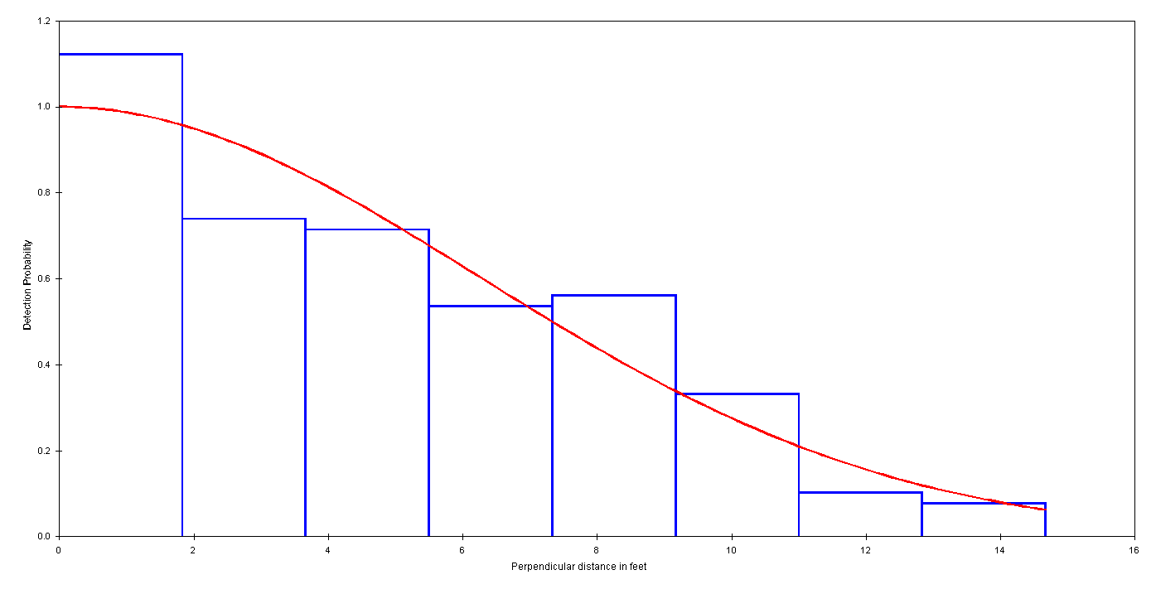
Figure 4. All adults and subadults model for age structured assessment with hazard rate key function and no binning and no truncation of data, 1.83 ft intervals shown.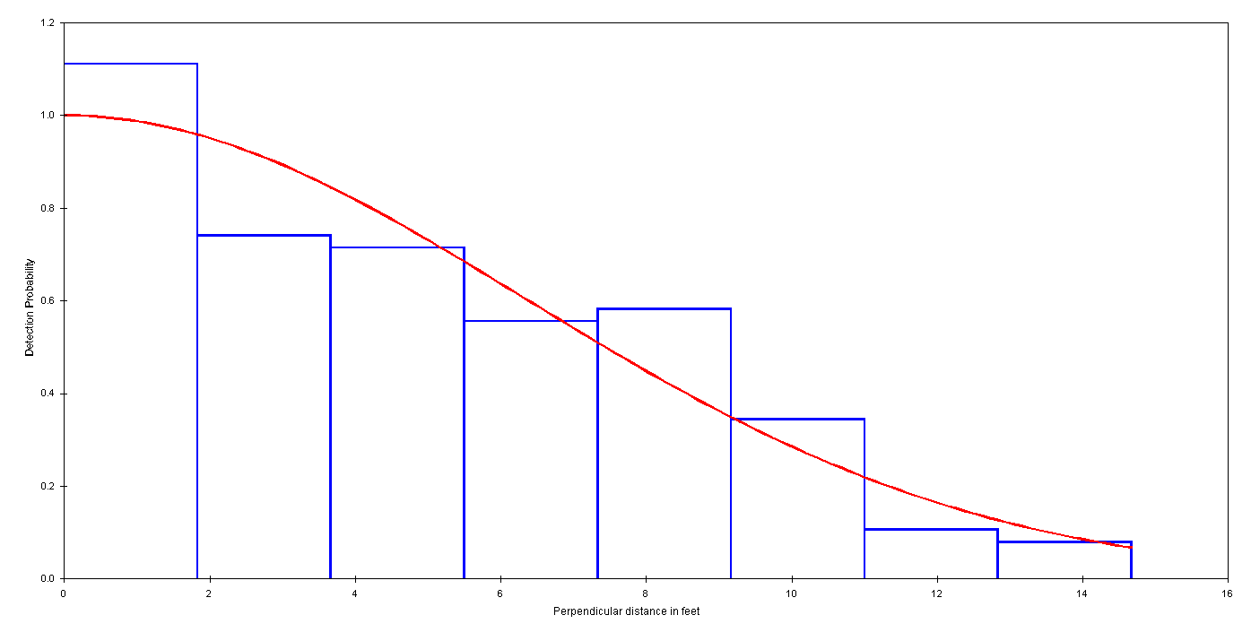
Figure 5. Model with all adults and subadults ≥340 mm and with no length information for SAFE with half normal key function and no binning or truncation, 1.83 ft intervals shown.
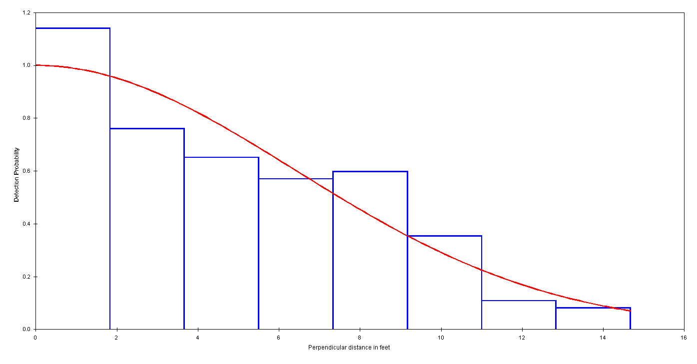
Figure 6. Model with all adults and subadults ≥340 mm for SAFE with half normal key function and no binning or truncation, 1.83 ft intervals shown.

Appendices

Results for all Models Explored by Analysis
Appendix 1. Analysis 1 for age structured model, includes all adults and all subadults. The preferred model for the age structured assessment has no binning or truncation (Appendix 1.A.).
Appendix 1.A. No binning or truncation, 164 observations, width 15
 | Hazard rate cosine | Half normal cosine
AIC | 814 | 814
Density (ye/km²) | 1213 | 1142
D LCL (ye/km²) | 894 | 870
D UCL (ye/km²) | 1645 | 1499
CV of D | 0.15 | 0.14
Judgement | OK shoulder and good fit but shape biologically unrealistic | OK shoulder, good fit, and good realistic shape.
X² P-value | 0.65 (1.83 ft bins), 0.59 (1.22 ft bins), 0.56(0.772 ft bins) | 0.47 (1.83 ft bins), 0.33 (1.22 ft bins), 0.48 (0.772 ft bins)
# parameters | 3 | 1
Q-q plot | Pretty good fit | Pretty good fit
K-S P-value | 0.92 | 0.82
warnings | None | None

Appendix 1.B. 1-ft bins, no truncation, 164 observations, width 15
 | Hazard rate cosine | Half normal cosine
AIC | 814 | 815
Density (ye/km²) | 1228 | 1153
D LCL (ye/km²) | 906 | 880
D UCL (ye/km²) | 1663 | 1512
CV of D | 0.15 | 0.14
Judgement | OK shoulder and shape but not good fit at some bins. | OK shoulder and shape but not good fit at some bins.
X² P-value | 0.27 | 0.16
# parameters | 3 | 1
warnings | None | None

Appendix 1.C. 1.5-ft bins, no truncation, 164 observations, width 15
 | Hazard rate cosine | Half normal cosine
AIC | 682 | 682
Density (ye/km²) | 1199 | 1156
D LCL (ye/km²) | 881 | 882
D UCL (ye/km²) | 1631 | 1515
CV of D | 0.16 | 0.14
Judgement | Good shoulder and good fit but not a realistic shape | Really good fit and shape and OK shoulder
X² P-value | 0.77 | 0.45
# parameters | 3 | 1
warnings | None | None

Appendix 1.D. 2-ft bins, no truncation, 165 observations, width 15
 | Hazard rate cosine | Half normal cosine
AIC | 588 | 591
Density (ye/km²) | 1371 | 1168
D LCL (ye/km²) | 984 | 892
D UCL (ye/km²) | 1909 | 1529
CV of D | 0.17 | 0.14
Judgement | Unrealistic shape | Good shape, OK fit
X² P-value | 0.23 | 0.04
# parameters | 4 | 1
warnings | Parameters are being constrained to monotonicity | None
Appendix 1.E. 2.5 ft bins, no truncation, 165 observations, width 15
 | Hazard rate cosine | Half normal cosine
AIC | 518 | 518
Density (ye/km²) | 1192 | 1148
D LCL (ye/km²) | 871 | 875
D UCL (ye/km²) | 1631 | 1506
CV of D | 0.16 | 0.14
Judgement | OK shoulder and fit but unrealistic shape | Good shape and fit and OK shoulder
X² P-value | 0.13 | 0.13
# parameters | 3 | 1
warnings | none | None

Appendix 1.F. No binning, truncation after 12ft, 159 observations, width 12
 | Hazard rate cosine* | Half normal cosine
AIC | 762 | 759
Density (ye/km²) | 1236 | 1133
D LCL (ye/km²) | 860 | 860
D UCL (ye/km²) | 1775 | 1493
CV of D | 0.19 | 0.14
Judgement | OK shoulder, shape and fit | Good shape and fit and OK shoulder
X² P-value | 0.14 (1.5 ft bins), 0.05 (0.1 ft bins), 0.21 (0.667 ft bins) | 0.33 (1.5 ft bins), 0.08 (1 ft bins), 0.30 (0.667 ft bins)
# parameters | 2 | 1
Q-q plot | Pretty good fit some deviation on end | OK fit with some deviation
K-S P-value | 0.78 | 0.75
warnings | Parameters being constrained to monotonicity | None

Appendix 1.G. 1 ft bins, truncation after 12ft, 159 observations, width 12ft
 | Hazard rate cosine | Half normal cosine
AIC | 761 | 758
Density (ye/km²) | 1242 | 1138
D LCL (ye/km²) | 866 | 865
D UCL (ye/km²) | 1782 | 1497
CV of D | 0.18 | 0.14
Judgement | OK shape but not a great fit at some bins | Not a great fit at some bins
X² P-value | 0.05 | 0.08
# parameters | 2 | 1
warnings | Parameters being constrained to monotonicity | None

Appendix 1.H. 1.5 ft bins, truncation after 12 ft bin, 159 observations, width 12 ft
 | Hazard rate cosine | Half normal cosine
AIC | 634 | 630
Density (ye/km²) | 1220 | 1137
D LCL (ye/km²) | 847 | 864
D UCL (ye/km²) | 1757 | 1496
CV of D | 0.19 | 0.14
Judgement | Good shoulder, good shape, and fit | OK shoulder, good fit and shape
X² P-value | 0.15 | 0.32
# parameters | 2 | 1
warnings | Parameters being constrained to monotonicity | None

Appendix 1.I. 2 ft bins, truncation after 12 ft, 159 observations, width 12 ft
 | Hazard rate cosine | Half normal cosine
AIC | 540 | 537
Density (ye/km²) | 1320 | 1281
D LCL (ye/km²) | 889 | 839
D UCL (ye/km²) | 1961 | 1957
CV of D | 0.20 | 0.22
Judgement | OK shape but not much shoulder | Unrealistic shape
X² P-value | 0.01 | 0.03
# parameters | 2 | 4
warnings | Parameters are being constrained to monotonicity | Parameters are being constrained to monotonicity

Appendix 1.J. 2.5 ft bins, truncation after 12 ft, 159 observations, width 12.5 ft
 | Hazard rate cosine | Half normal cosine
AIC | 471 | 472
Density (ye/km²) | 1240 | 1156
D LCL (ye/km²) | 845 | 879
D UCL (ye/km²) | 1815 | 1520
CV of D | 0.19 | 0.14
Judgement | Not biologically realistic | OK fit and shape
X² P-value | Test not possible | 0.07
# parameters | 4 | 1
warnings | Parameters being constrained to monotonicity; parameters reduced | Parameters reduced
Appendix 2. Analysis 2 for SAFE, includes all adults and subadults ≥ 340 mm and with no length information. The preferred model for the SAFE has no binning or truncation (Appendix 2.A.).
Appendix 2.A. No binning or truncation, 160 observations, width 14.67
 | Hazard rate cosine | Half normal cosine
AIC | 797 | 797
Density (ye/km²) | 1158 | 1101
D LCL (ye/km²) | 846 | 833
D UCL (ye/km²) | 1583 | 1454
CV of D | 0.16 | 0.14
Judgement | Very wide shoulder but OK shape; bad fit at some distance intervals | Good shape and OK fit but no shoulder
X² P-value | 0.68 (1.83 ft bins), 0.56 (1.22 ft bins), 0.21 (0.815 ft bins) | 0.46 (1.83 ft bins), 0.29 (1.22 ft bins), 0.13 (0.815 ft bins)
# parameters | 2 | 1
Q-q plot | OK fit with some large deviation in middle | Some deviation, especially in middle
K-S P-value | 0.96 | 0.87
warnings | None | None

Appendix 2.B. 1-ft bins, no truncation, 160 observations, width 15
 | Hazard rate cosine | Half normal cosine
AIC | 797 | 798
Density (ye/km²) | 1171 | 1111
D LCL (ye/km²) | 857 | 843
D UCL (ye/km²) | 1601 | 1466
CV of D | 0.16 | 0.24
Judgement | Unrealistic shape | No shoulder; good shape but not great fit at some intervals
X² P-value | 0.41 | 0.19
# parameters | 3 | 1
warnings | None | None

Appendix 2.C. 1.5-ft bins, no truncation, 160 observations, width 15
 | Hazard rate cosine | Half normal cosine
AIC | 667 | 668
Density (ye/km²) | 1148 | 1115
D LCL (ye/km²) | 837 | 846
D UCL (ye/km²) | 1575 | 1471
CV of D | 0.16 | 0.14
Judgement | Not realistic shape | No shoulder but ok fit
X² P-value | 0.75 | 0.42
# parameters | 3 | 1
warnings | Parameters are being constrained to monotonicity | None

Appendix 2.D. 2-ft bins, no truncation, 160 observations, width 16
 | Hazard rate cosine | Half normal cosine
AIC | 577 | 579
Density (ye/km²) | 1300 | 1125
D LCL (ye/km²) | 924 | 854
D UCL (ye/km²) | 1829 | 1482
CV of D | 0.17 | 0.14
Judgement | Unrealistic shape | Good fit and good shape but not much of a shoulder. Bad fit at some intervals
X² P-value | 0.24 | 0.04
# parameters | 4 | 1
warnings | Parameters are being constrained to monotonicity | Parameters are being constrained to monotonicity
Appendix 2.E. 2.5 ft bins, no truncation, 160 observations, width 15
 | Hazard rate cosine | Half normal cosine
AIC | 508 | 507
Density (ye/km²) | 1137 | 1106
D LCL (ye/km²) | 823 | 838
D UCL (ye/km²) | 1569 | 1460
CV of D | 0.16 | 0.14
Judgement | Unrealistic shape | Good fit and shape but no shoulder
X² P-value | 0.13 | 0.12
# parameters | 3 | 1
warnings | None | None

Appendix 2.F. No binning, truncation after 12ft, 155 observations, width 12
 | Hazard rate cosine* | Half normal cosine
AIC | 745 | 742
Density (ye/km²) | 832 | 1088
D LCL (ye/km²) | 645 | 819
D UCL (ye/km²) | 1075 | 1446
CV of D | 0.13 | 0.14
Judgement | Large shoulder, not great fit at some bins | OK shape and fit but not much shoulder
X² P-value | 0.06 (1.5 ft bins), 0.04 (1 ft bins), 0.18 (0.667 ft bins) | 0.29 (1.5 ft bins), 0.15 (1 ft bins), 0.39 (0.667 ft bins)
# parameters | 2 | 1
Q-q plot | Bad fit in middle | Lots of deviation in the middle
K-S P-value | 0.004 | 0.86
warnings | Parameters being constrained to monotonicity | None

Appendix 2.G. 1 ft bins, truncation after 12ft, 155 observations, width 12ft
 | Hazard rate cosine | Half normal cosine
AIC | 744 | 741
Density (ye/km²) | 1195 | 1093
D LCL (ye/km²) | 822 | 824
D UCL (ye/km²) | 1737 | 1449
CV of D | 0.19 | 0.14
Judgement | Good fit and shape with a little shoulder | Good fit and shape but not at all bins
X² P-value | 0.08 | 0.14
# parameters | 2 | 1
warnings | Parameters being constrained to monotonicity | None

Appendix 2.H. 1.5 ft bins, truncation after 15 ft bin, 155 observations, width 12 ft
 | Hazard rate cosine | Half normal cosine
AIC | 620 | 616
Density (ye/km²) | 1192 | 1093
D LCL (ye/km²) | 812 | 824
D UCL (ye/km²) | 1748 | 1450
CV of D | 0.20 | 0.14
Judgement | Good shape with a small shoulder and OK fit at most bins | Good fit and shape but not much of a shoulder
X² P-value | 0.13 | 0.28
# parameters | 2 | 1
warnings | Parameters being constrained to monotonicity | None

Appendix 2.I. 2 ft bins, truncation after 12 ft, 155 observations, width 12 ft
 | Hazard rate cosine | Half normal cosine
AIC | 529 | 526
Density (ye/km²) | 1261 | 1418
D LCL (ye/km²) | 837 | 996
D UCL (ye/km²) | 1901 | 2020
CV of D | 0.21 | 0.18
Judgement | OK shape but quick drop at origin | Unrealistic shape
X² P-value | 0.01 | 0.04
# parameters | 2 | 3
warnings | Parameters are being constrained to monotonicity | Parameters are being constrained to monotonicity

Appendix 2.J. 2.5 ft bins, truncation after 12 ft, 155 observations, width 12.5 ft
 | Hazard rate cosine | Half normal cosine
AIC | 462 | 462
Density (ye/km²) | 1182 | 1111
D LCL (ye/km²) | 798 | 838
D UCL (ye/km²) | 1749 | 1473
CV of D | 0.20 | 0.14
Judgement | Weird shape | Good shape and fit
X² P-value | No test possible | 0.06
# parameters | 4 | 1
warnings | Parameters are being constrained to monotonicity; Number adjustment parameters allowed limited | Number adjustment parameters allowed limited
Appendix 3. Analysis 3 for SAFE, includes all adults and subadults ≥ 340 mm. The preferred model for the SAFE has no binning or truncation (Appendix 3.A.).
Appendix 3.A. No binning or truncation, 157 observations, width 15
 | Hazard rate cosine | Half normal cosine
AIC | 783 | 784
Density (ye/km²) | 1131 | 1073
D LCL (ye/km²) | 828 | 813
D UCL (ye/km²) | 1545 | 1416
CV of D | 0.16 | 0.14
Judgement | Unrealistic shape | Good fit and shape but not much shoulder
X² P-value | 0.66 (1.83 ft bins), 0.53 (1.22 ft bins), 0.22 (0.82 ft bins) | 0.40 (1.83 ft bins), 0.24 (1.22 ft bins), 0.12 (0.82 ft bins)
# parameters | Good fit | 1
Q-q plot | Some deviation in middle and beginning | Some deviation
K-S P-value | 0.95 | 0.81
warnings | Parameters are being constrained to monotonicity | None

Appendix 3.B. 1-ft bins, no truncation, 157 observations, width 15
 | Hazard rate cosine | Half normal cosine
AIC | 783 | 785
Density (ye/km²) | 1138 | 1082
D LCL (ye/km²) | 832 | 821
D UCL (ye/km²) | 1556 | 1426
CV of D | 0.16 | 0.14
Judgement | Unrealistic shape | No shoulder; good shape and fit1
X² P-value | 0.49 | 0.26
# parameters | 3 | 1
warnings | Parameters are being constrained to monotonicity | None

Appendix 3.C. 1.5-ft bins, no truncation, 157 observations, width 15
 | Hazard rate cosine | Half normal cosine
AIC | 656 | 657
Density (ye/km²) | 1118 | 1086
D LCL (ye/km²) | 814 | 824
D UCL (ye/km²) | 1535 | 1432
CV of D | 0.16 | 0.14
Judgement | Not realistic shape | No shoulder but ok fit
X² P-value | 0.68 | 0.34
# parameters | 3 | 1
warnings | Parameters are being constrained to monotonicity | None

Appendix 3.D. 2-ft bins, no truncation, 157 observations, width 16
 | Hazard rate cosine | Half normal cosine
AIC | 568 | 571
Density (ye/km²) | 1259 | 1094
D LCL (ye/km²) | 893 | 832
D UCL (ye/km²) | 177 | 1440
CV of D | 0.17 | 0.14
Judgement | Unrealistic shape | Good fit and good shape but not much of a shoulder
X² P-value | 0.25 | 0.04
# parameters | 4 | 1
warnings | Parameters are being constrained to monotonicity | Parameters are being constrained to monotonicity
Appendix 3.E. 2.5 ft bins, no truncation, 157 observations, width 15
 | Hazard rate cosine | Half normal cosine
AIC | 500 | 499
Density (ye/km²) | 1108 | 1078
D LCL (ye/km²) | 801 | 817
D UCL (ye/km²) | 1530 | 1421
CV of D | 0.16 | 0.14
Judgement | Unrealistic fit | Good fit and shape but no shoulder
X² P-value | 0.10 | 0.09
# parameters | 3 | 1
warnings | Parameters being constrained to monotonicity | None

Appendix 3.F. No binning, truncation after 12ft, 152 observations, width 12
 | Hazard rate cosine* | Half normal cosine
AIC | 732 | 728
Density (ye/km²) | 1200 | 1059
D LCL (ye/km²) | 807 | 798
D UCL (ye/km²) | 1786 | 1407
CV of D | 0.20 | 0.14
Judgement | OK shape and fit but bad at end | OK shape and fit but not much shoulder
X² P-value | 0.12 (1.5 ft bins), 0.11 (1 ft bins), 0.35 (0.667 ft bins) | 0.23 (1.5 ft bins), 0.17 (1 ft bins), 0.41 (0.667 ft bins)
# parameters | 2 | 1
Q-q plot | Pretty good fit but some deviation at end | Lots of deviation in the middle
K-S P-value | 0.71 | 0.73
warnings | Parameters being constrained to monotonicity | None

Appendix 3.G. 1 ft bins, truncation after 12ft, 152 observations, width 12ft
 | Hazard rate cosine | Half normal cosine
AIC | 731 | 728
Density (ye/km²) | 1184 | 1062
D LCL (ye/km²) | 805 | 801
D UCL (ye/km²) | 1741 | 1408
CV of D | 0.11 | 0.14
Judgement | Good fit and shape | Good fit and shape
X² P-value | 0.6 | 0.17
# parameters | 2 | 1
warnings | Parameters being constrained to monotonicity | None

Appendix 3.H. 1.5 ft bins, truncation after 12 ft bin, 152 observations, width 12 ft
 | Hazard rate cosine | Half normal cosine
AIC | 609 | 605
Density (ye/km²) | 1210 | 1063
D LCL (ye/km²) | 802 | 802
D UCL (ye/km²) | 1825 | 1410
CV of D | 0.21 | 0.14
Judgement | Good shoulder and good fit | Good shoulder and good fit
X² P-value | 0.12 | 0.22
# parameters | 2 | 1
warnings | Parameters being constrained to monotonicity | None

Appendix 3.I. 2 ft bins, truncation after 10 ft, 122 observations, width 10 ft
 | Hazard rate cosine | Half normal cosine
AIC | 520 | 516
Density (ye/km²) | 1285 | 1376
D LCL (ye/km²) | 806 | 964
D UCL (ye/km²) | 2051 | 1964
CV of D | 0.24 | 0.18
Judgement | Unrealistic shape | Unrealistic shape
X² P-value | 0.01 | 0.06
# parameters | 2 | 3
warnings | Parameters are being constrained to monotonicity; parameters constrained to lower bound | Parameters are being constrained to monotonicity

Appendix 3.J. 2.5 ft bins, truncation after 12 ft, 152 observations, width 12 ft
 | Hazard rate cosine | Half normal cosine
AIC | 453 | 455
Density (ye/km²) | 1153 | 1081
D LCL (ye/km²) | 777 | 816
D UCL (ye/km²) | 1710 | 1432
CV of D | 0.20 | 0.14
Judgement | Unrealistic fit | OK fit
X² P-value | No test could be done | 0.04
# parameters | 4 | 1
warnings | Parameters are being constrained to monotonicity | Number adjustment parameters allowed limited

In 2012, 7 subadults less than <340 mm and 1 subadult with no length data were excluded.
In 2013, no subadults were less than <340 mm. 17 subadults with no length data were included.
In 2015, 4 subadults were less than <340 mm and excluded from the SAFE model. Two subadults had no length and were included.
In 2016 NSEO, 30 subadults were <340 mm and excluded from the SAFE model. Fifteen subadults had no length and were excluded as well.
In 2016 CSEO, 4 subadults were <340 mm and excluded from this SAFE model.
In 2016 CSEO, 4 subadults were <340 mm and excluded from this SAFE model. Three subadults with no length were excluded as well.
These counts do not include fish that were removed from the models due to truncation.
No belly camera was used in 2012 and 2013, so it is possible that some juveniles and/or subadults were missed during video review.
No forward facing camera was used in 1994, so some juveniles and subadults may have been missed.

